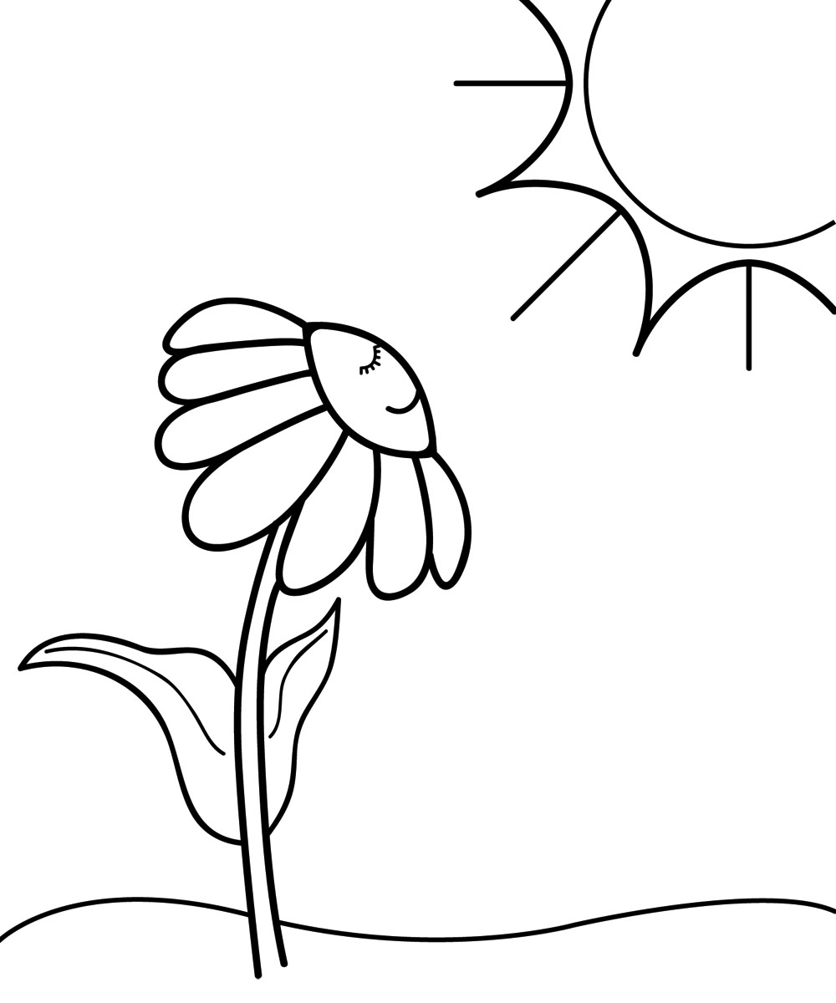
Name: _________________
Period: ____ Date: _______
Light and Dark
Four friends were talking about when plants carry out the process of photosynthesis and respiration. This is what they said:
Janet: “Photosynthesis occurs in the light; plants don’t carry out the process of respiration”
Calvin: “Photosynthesis occurs when it is light; respiration occurs when it is dark.”
Mika: “Photosynthesis occurs when it is light; respiration occurs both when it is light and when it is dark.”
Turner: “Photosynthesis occurs both when it is light and when it is dark; respiration happens at night.”

With whom do you agree the most? _________________________________
On the back explain why you agree with that person and not the others.
Adapted from Page Keeley’s Uncovering Student Ideas in Life Science, VOL.1, NSTA press, 2011

Name: _________________
Period: ____ Date: _______
Light and Dark

Four friends were talking about when plants carry out the process of photosynthesis and respiration. This is what they said:
Janet: “Photosynthesis occurs in the light; plants don’t carry out the process of respiration”
Calvin: “Photosynthesis occurs when it is light; respiration occurs when it is dark.”
Mika: “Photosynthesis occurs when it is light; respiration occurs both when it is light and when it is dark.”
Turner: “Photosynthesis occurs both when it is light and when it is dark; respiration happens at night.”

With whom do you agree the most? _________________________________
On the back explain why you agree with that person and not the others.

Adapted from Page Keeley’s Uncovering Student Ideas in Life Science, VOL.1, NSTA press, 2011

